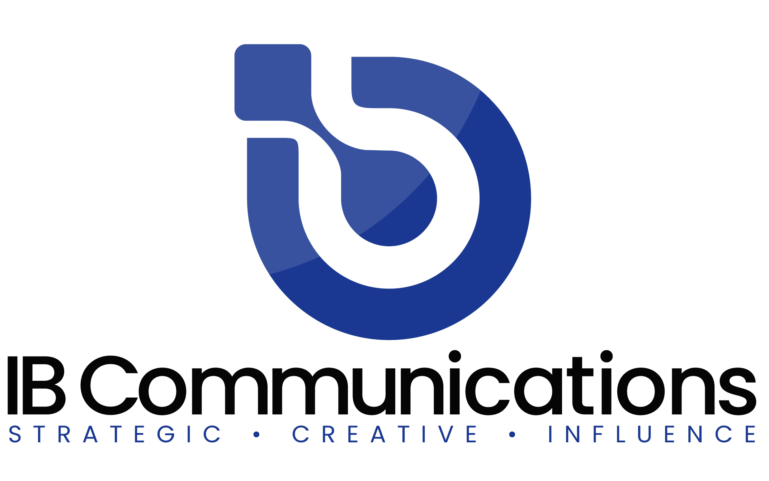

Press Release
Media Contacts:
IB Communications
Tel +44 (0)20 89434685
isct@ibcomms.agency

ISCT issues response to US federal judge ruling on FDA regulation of cell and gene therapies

- US federal judge ruling of significant concern, with widespread implications for cell and gene therapy sector as well as patient safety

Vancouver, Canada, September 12, 2022 - The International Society for Cell & Gene Therapy (ISCT), the global society of clinicians, researchers, regulators, technologists, and industry partners dedicated to the translation of cell and gene therapy (CGT) into safe and effective therapies to improve patients' lives, today announces its initial sector leadership response to, and concern about, the recent US federal court ruling in favor of California Stem Cell Treatment Center, Inc., and Cell Surgical Network Corporation, asserting “that neither Defendants’ SVF Surgical Procedure nor its Expanded MSC Procedure are “drugs” within the meaning of the Federal Food, Drug, and Cosmetic Act.”

ISCT believes that this ruling is flawed and has inserted regulatory uncertainty into the CGT market, creating opportunities for clinics offering purported treatments that are scientifically unproven and potentially dangerous to patients.

ISCT is concerned that scientific inaccuracies in the ruling may have impacted Judge Bernal’s decision. The ISCT Committee on the Ethics of Cell and Gene Therapy identified several examples of statements that are problematic and unfounded.

Firstly, the ruling made several statements concerning stromal vascular fraction (SVF) that are both inaccurate and unsupported by current scientific knowledge. The ruling mistakenly claims the production of SVF is essentially equivalent to surgery and mischaracterizes SVF as a naturally occurring, circulating, unaltered biological entity that is simply relocated from adipose tissue to other diseased parts of the body by surgical means.

Secondly, the assertion that the clinical networks use FDA-authorized devices to produce autologous stem cell-based interventions does not take into account that the devices in question may not have been authorized by the FDA, or authorized for other purposes, and have not been designed for the production of stem cell therapies.

Thirdly, the statement that culture-expanded mesenchymal stem cells (MSCs) should not be regulated as drugs conflicts with scientific evidence. This statement opens the door to unchecked administration of poorly characterized and non-standardized cell preparations with unknown safety and efficacy and may pose significant risks to patients.

ISCT is committed to the development of evidence-based stem cell therapies and acknowledges the vital role of regulatory bodies such as the US FDA. ISCT will continue to develop tools and educational resources that support and promote the development of safe and effective CGTs globally.

Speaking on the ruling Laertis Ikonomou, PhD, Chair, ISCT Committee on the Ethics of Cell and Gene Therapy said, "ISCT has worked for many years now, alongside the FDA and other regulators across the globe, to ensure all those offering cell and gene, and advanced therapies, operate within established clinical regulatory frameworks to uphold scientific standards and ensure treatments are safe and effective before they reach patients. CGTs currently hold unparalleled potential to treat a vast range of conditions that are underserved needs. However, as one of the most advanced and novel fields of medicine, enhancing patient's own cells, these therapies must operate entirely through a global regulatory framework subject to the most stringent scientific standards."

ISCT President Jacques Galipeau, MD, commented, "This ruling introduces regulatory uncertainty into the CGT market, and unscrupulous clinics prey on this uncertainty to market unproven interventions to patients. The ruling reinforces the imperative market need for informative resources that establish scientific consensus, standards, and best practices. ISCT will continue to work with FDA and other like-minded national and international organizations and regulatory agencies to achieve ISCT’s mission to drive clinical translation of cell and gene therapies worldwide."

ENDS

About the International Society for Cell & Gene Therapy
Established in 1992, the International Society for Cell & Gene Therapy (ISCT) is a global society of clinicians, regulators, researchers, technologists, and industry partners with a shared vision to translate cell and gene therapy into safe and effective therapies to improve patients' lives worldwide.
ISCT is the global leader focused on pre-clinical and translational aspects of developing cell and gene-based therapeutics, thereby advancing scientific research into innovative treatments for patients. ISCT offers a unique collaborative environment that addresses three key areas of translation: Academia, Regulatory, and Commercialization. Through strong relationships with global regulatory agencies, academic institutions, and industry partners, ISCT drives the advancement of research into a standard of care. Comprised of over 2,700 cell and gene therapy experts across five geographic regions and representation from over 60 countries, ISCT members are part of a global community of peers, thought leaders, and organizations invested in cell and gene therapy translation. For more information about the society, key initiatives, and upcoming meetings, please visit https://isctglobal.org, @ISCTglobal.

