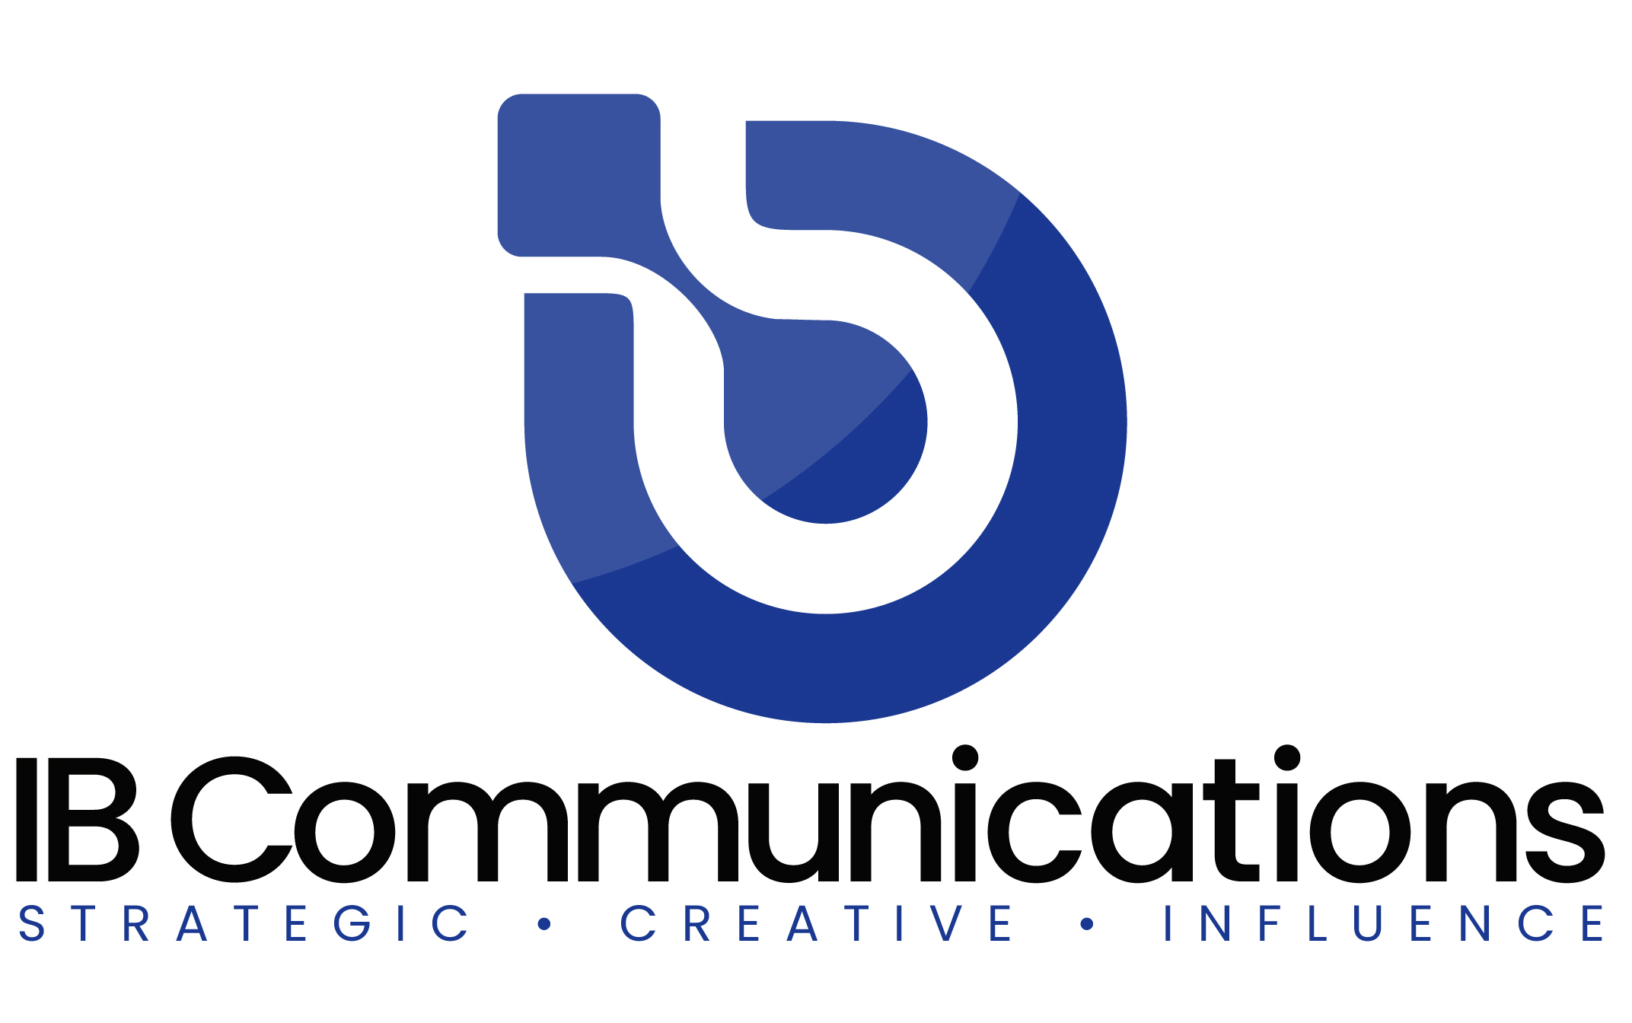

Press Release
Media Contacts:
IB Communications
Tel +44 (0)20 89434685
bone@ibcomms.agency

Bone Therapeutics reports half year 2022 results

- Bone Therapeutics acquires majority participation in Medsenic to derisk and broaden its therapeutic portfolio[1]
- Preparation of the Medsenic Phase III clinical trial with oral formulation following positive results from Phase II arsenic trioxide in the first-line treatment of cGvHD (chronic GvH)
- Bone Therapeutics ALLOB’s Phase IIb interim results expected in H1 2023

Mont-Saint-Guibert, Belgium, September 7, 2022 – BONE THERAPEUTICS (Euronext Brussels and Paris: BOTHE), the cell therapy company addressing unmet medical needs in orthopedics and other diseases, today announces its business update for the first half, ended 30 June 2022, prepared in accordance with IFRS as adopted by the European Union, and the outlook for the remainder of the year. The update also includes the Company’s reverse merger with Medsenic; a biopharmaceutical company specializing in developing therapies for autoimmune diseases.

“Following the conclusion of activity in the first half of 2022, Bone Therapeutics has consolidated its successes and outlined its plans for the rest of the year. Having optimized the statistical analysis for the ongoing Phase IIb clinical study for our allogeneic cell therapy product, ALLOB, we are now of the view that ALLOB has the highest potential of near-term value creation. This is based on the successful completion of two clinical studies showing promising safety profile and efficacy signals in 66 patients,” said Jean Stéphenne, President of Bone Therapeutics. “Having built strong foundations, we now believe we will be able to maximize the productivity of the second half of the year. We are now looking forward to the continued development of our therapeutic pipeline, to bring these life-changing therapies to patients worldwide.”

Operational and Corporate highlights
- In March 2022, Bone Therapeutics realigned its strategic priorities to fully concentrate on the clinical development of its most advanced asset, ALLOB.
- In May 2022, Bone Therapeutics entered into a non-binding term sheet and exclusive discussions for a period of three months with the shareholders of Medsenic. Medsenic is a privately held, clinical stage biopharmaceutical company incorporated in France, specializing in the development of optimized formulations of arsenic salts and their application in inflammatory conditions and other potential new indications.
- In July 2022, Bone Therapeutics announced an optimized statistical analysis and the implementation of an interim analysis for the ongoing Phase IIb clinical trial with its allogeneic bone cell therapy product, ALLOB. With the improved statistical analysis, the number of required patients could be reduced by 20 percent. The interim analysis will be added to the study providing an early assessment of ALLOB’s efficacy based on radiological data of the first 66 evaluable patients and more stringent efficacy end point criteria.
- In August 2022, Bone Therapeutics and Medsenic announced the signature of a binding contribution agreement to combine the operations of both companies by means of a share for share exchange, subject to the approval of the shareholders' meeting. The acquisition will result in the business combination of Bone Therapeutics and Medsenic to create BioSenic, a speciality biopharma company. 51 percent of Medsenic shares (valued at around EUR 40 million) will be contributed at a subscription price per share of EUR 0.45. In addition, each existing share will be entitled to subscribe to one additional share at EUR 0.45 in case of successful ALLOB interim results. Bone Therapeutics aims to acquire the remaining outstanding capital of Medsenic within 24 to 36 months. Following the completion of the Business Combination, it is anticipated that the executive leadership team will bring in François Rieger (CEO) and Véronique Pomi-Schneiter (Executive Director).

Financial highlights
- In April 2022, Bone Therapeutics signed a binding term sheet for a EUR 5 million convertible bonds (CBs) facility arranged by ABO Securities. The proceeds of the financing will be particularly used to advance the clinical development of Bone Therapeutics’ lead asset, ALLOB. At the end of May 2022, Bone Therapeutics signed the definitive subscription agreement for a maximum EUR 5 million CBs facility with ABO Securities. The CBs will be issued and subscribed in ten tranches.
- During the first six months of 2022, total operating income amounted to EUR 0.40 million, a slight decrease compared to the same period in 2021 (EUR 0.77 million).
- Operating loss for the period amounted to EUR 3.96 million, compared to EUR 5.72 million in H1 2021.
- The Company ended the first six months of 2022 with EUR 3.96 million in cash and cash equivalents. Net cash used for the period amounted to EUR 5.55 million, compared to EUR 8.63 million over the same period of 2021.
- The combined group is expected to have a proforma cash position of at least EUR 5 million at closing. The Company plans to raise funds in the form of a private placement of new shares at the end of 2022 in order to finance the combined activities of Medsenic and the Company. In the meantime, the Company will make use of the existing EUR 5 million convertible facility obtained via ABO to finance its activities and to finance the convertible loan granted to Medsenic for of up to EUR 2 million, to secure their projects during this period.
- Disciplined cost and cash management will remain a key priority. The operating cash burn for the full year 2022 is expected to be in the range of EUR 8-10 million and a financing cash burn of approximately EUR 1.3 million, assuming normal operation as we continue to feel the effects of the COVID-19 pandemic.
- Based on the completion of the current CB financing operation as mentioned above and the announced sole focus on the completion of the ALLOB TF2 study with related downsizing of the company, the Board is of the opinion that it is appropriate to prepare the 2022 interim financial statements of the Company under the assumption of going concern, considering a projected operational cash burn of EUR 8 to 10 million for 2022 and a cash runway into Q1 2023.

Outlook for the remainder of 2022 and 2023
- The transaction between Bone Therapeutics and Medsenic is subject to the approval of the contribution by Bone Therapeutics' shareholders at an extraordinary shareholders’ meeting (‘ESM’) to be convened by the Board of Bone Therapeutics in the course of September 2022. The transaction is also subject to certain other customary conditions including the confirmation that the proposed Business Combination would not lead to the necessity, for any subscriber involved to launch a mandatory takeover bid on Bone Therapeutics.
- The Phase IIb trial of Bone Therapeutics’ ALLOB, a randomized, double-blind, placebo-controlled study in patients with high-risk tibial fractures, is still ongoing and set to report important interim results in the first half of 2023.
- The Medsenic Phase II clinical study with arsenic trioxide in the first-line treatment of cGvHD (chronic GvH) is complete and provided positive results. A phase IIa clinical trial for Lupus had previously established proof of concept of safety for the patient and efficacy on the course of the autoimmune disease: a Phase 2b clinical trial for severe Lupus is in the planning stage. A Phase III study of cGvHD is also currently anticipated to start in 2023. Also, positive preclinical work gives good grounds for a Phase 2 clinical trial on systemic sclerosis.
- The reverse merger between Bone Therapeutics and Medsenic will soon lead to a new company, BioSenic. The new company plans to accelerate its development-mainly based upon clinical research, and will raise funds, in the form of a first private placement of new shares at the end of 2022, in order to finance its combined activities.

More information about the report you can find here.

[1]Subject to the approval of the shareholders’ meeting

About Bone Therapeutics
Bone Therapeutics is a leading biotech company focused on the development of innovative products to address high unmet needs in orthopedics and other diseases. Currently Bone Therapeutics is concentrating specifically on the development of its most advanced clinical asset, the allogeneic cell therapy platform, ALLOB.
Bone Therapeutics’ core technology is based on its cutting-edge allogeneic cell and gene therapy platform with differentiated bone marrow sourced Mesenchymal Stromal Cells (MSCs) which can be stored at the point of use in the hospital. Its leading investigational medicinal product, ALLOB, represents a unique, proprietary approach to bone regeneration, which turns undifferentiated stromal cells from healthy donors into bone-forming cells. These cells are produced via the Bone Therapeutics’ scalable manufacturing process. Following the CTA approval by regulatory authorities in Europe, the Company has initiated patient recruitment for the Phase IIb clinical trial with ALLOB in patients with difficult tibial fractures, using its optimized production process. ALLOB continues to be evaluated for other orthopedic indications including spinal fusion, osteotomy, maxillofacial and dental.
Bone Therapeutics’ cell therapy products are manufactured to the highest GMP (Good Manufacturing Practices) standards and are protected by a broad IP (Intellectual Property) portfolio covering ten patent families as well as knowhow. The Company is based in the Louvain-la-Neuve Science Park in Mont-Saint-Guibert, Belgium. Further information is available at www.bonetherapeutics.com.

About Medsenic SAS
Medsenic innovates and exploits the new possibilities offered by the therapeutic use of arsenic trioxide in several autoimmune diseases and is currently in clinical trials in Europe. The company was founded in 2010 by François Rieger, former Director of Research at the CNRS (French National Centre for Scientific Research) and author of more than 170 international scientific publications, and Véronique Pomi-Schneiter, former founder and manager of a consulting company specializing in human ressources, communication and development strategy. Under the aegis of a high-level scientific board, chaired by the 2011 Nobel Prize in Medicine Jules Hoffmann, a specialist in innate immunology, and supported by selected private investors, Medsenic accelerated its development in 2016 with the arrival of professional investors. Further information is available at www.medsenic.com.

