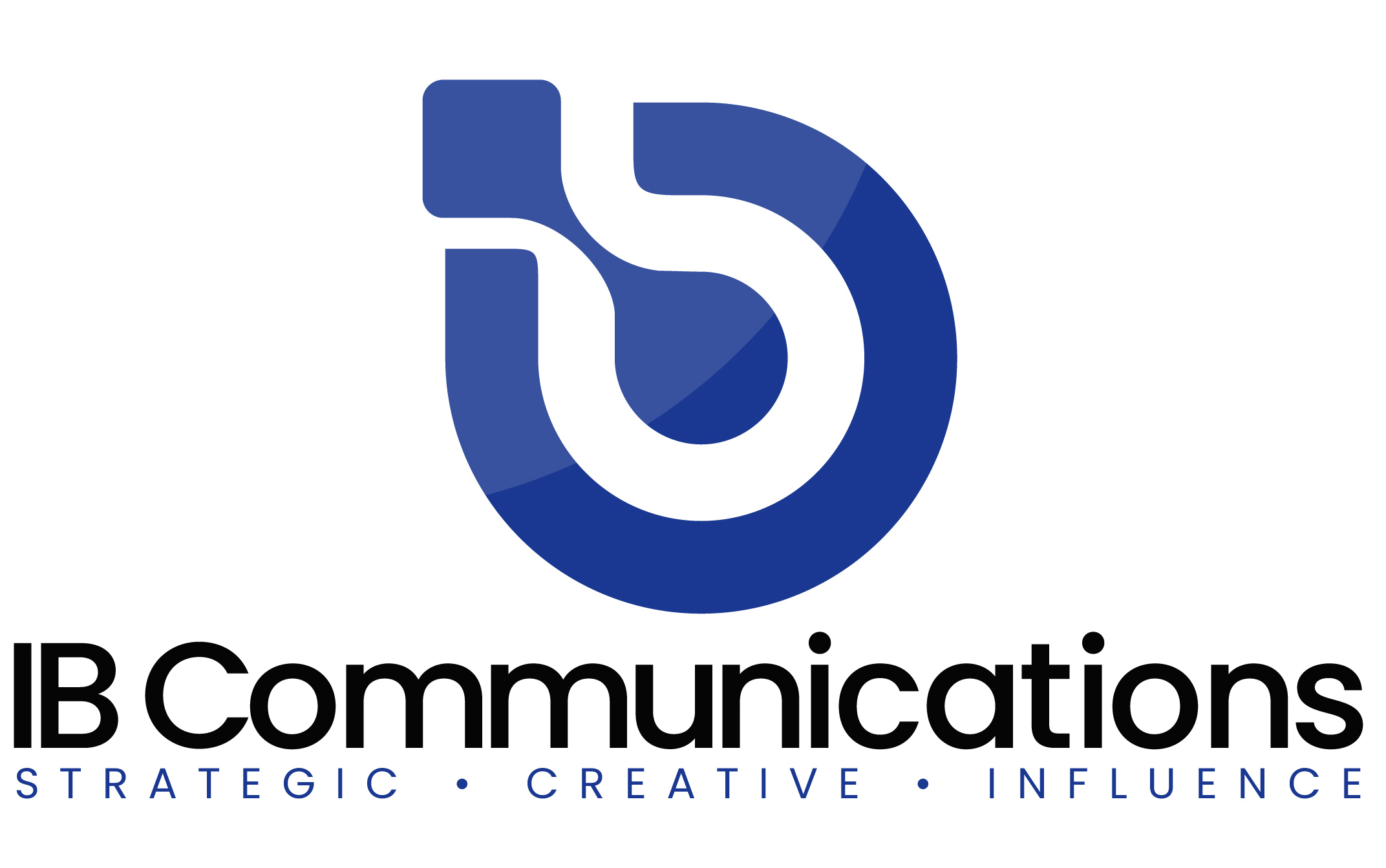

Press Release
Contact Information:
IB Communications
Tel +44 (0)20 8943 4685
trakcel@ibcomms.agency

TrakCel and ZS partner to advance cell and gene therapy orchestration through AI and technology

Enhanced data analytics to provide CGT sector with technological support as advanced as the development of CGTs

Cardiff, UK, October 13, 2022 - TrakCel, the leading supplier of cellular orchestration solutions for clinical trials and commercial therapies to the cell and gene therapy (CGT) industry, today announces the signing of a strategic partnership with ZS, a management consulting and technology firm focused on transforming global healthcare.

The partnership, which will bring together expertise across North America and Europe, is the first in the cell and gene industry specifically formed to apply enhanced data analytics, including artificial intelligence, to further streamline the CGT value chain. Enhanced analytics will provide vital dynamic data and trend analysis to enable greater informed decision-making processes.

“TrakCel is moving into its second decade of CGT supply chain orchestration by working within the market to develop a next generation of features that will provide first hand assistance to the CGT sector and make significant improvements to how therapies are manufactured and delivered,” said Dr Fiona Withey, Chief Executive Officer, TrakCel. “CGTs themselves are futuristic in the healthcare they provide, intervening at the cellular level to create revolutionary outcomes to patients suffering from indications with few current options. Many supply chains, however, are still relying on twentieth century technology to deliver these futuristic therapies. TrakCel does not believe this is acceptable, effective or safe. As a result, it is forming partnerships to enhance the technology available to the sector, ensuring it is as advanced as the therapies themselves. TrakCel’s partnership with ZS will result in the first holistic analytics in the market that will support CGT developers to proactively forecast and manage the value chains that deliver therapies to patients in the future.”

The TrakCel partnership with ZS aims to contribute proactive analysis and forecasting to further reduce treatment times, product loss and resource waste, and through this, reduce the overall cost of CGTs around the world. The partnership aims to extend supply chain orchestration from purely the visibility of supply chain progress into end-to-end order orchestration implementation and being able to take present-day action, to planning to amend and enhance the supply chain to increase efficiencies and reduce delivery times and costs.

TrakCel has selected ZS as a data analytics partner for its track record and achievements in data management and analytics, as well as for ZS’s experience with data analytics in the healthcare sector and the CGT sector. TrakCel will also be able to fit the analytics from ZS within its orchestration platform to provide additional intelligence to its supply chain partners and across those involved within the value chain.

As therapies target a broader range of indications and manufacturing processes increase in variety, the CGT supply and value chains are continuing to increase in complexity and number of interdependent organizations. CGTs still involve a number of precise processes that need to happen quickly and in a specific order, and the increasing number of participating companies involved adds pressure to the delivery of safe effective therapies to patients.

Both TrakCel and ZS believe that collecting granular data through TrakCel’s OCELLOS platform and applying detailed analytics could identify intelligence, predictions and trends that will reduce risks throughout the supply chains. Potential applications include the analysis of data from across the entire value chain to identify common points of failure, or the optimal routing of a product between partners and treatment sites based on historical data. This also has the potential to facilitate pre-emptive remedial action before minor points of failure become critical or recurrent. In addition, global supply chain data visibility could provide improvements in patient treatment times or locations.

“At ZS, we’re excited to add TrakCel to our global ecosystem of partners as we seek to help clients tackle their challenges,” said Sankalp Sethi, Principal and Cell and Gene Therapy Practice Lead at ZS. “We look forward to deploying our expertise to help the industry shift to using proactive, predictive analyses that can identify and mitigate challenges in cell therapy orchestration. We’ll continue to build partnerships with companies like TrakCel that are passionate about applying technology, data and analytics to improve decision-making and outcomes for cell and gene therapies to help more patients worldwide.”

End

About ZS
ZS is a management consulting and technology firm focused on transforming global healthcare and beyond. We leverage our leading-edge analytics, plus the power of data, science and products, to help our clients make more intelligent decisions, deliver innovative solutions and improve outcomes for all. Founded in 1983, ZS has more than 12,000 employees in 35 offices worldwide. To learn more, visit https://www.zs.com/or follow us on Twitter and LinkedIn.

About TrakCel
TrakCel is the market leading developer of integrated cell orchestration solutions. TrakCel has specifically designed these solutions to manage the international autologous and allogeneic cell, gene and immunotherapy value and supply chains. Its platform has evolved in collaboration with, and is increasingly adopted by, leading companies in the cell, gene and immunotherapy industries. TrakCel’s solutions enable real-time control for all organizations working across the entire therapeutic value chain. This control includes patient eligibility (commercial) and enrolment, sample collection, manufacturing and treatment delivery. The TrakCel platform accelerates global scale-up and scale-out of cell and gene therapy products, increasing efficiency and decreasing complexity, while safe-guarding Chain of Custody and Chain of Identity with a full electronic audit trail for administration compliance and traceability. TrakCel was founded in 2012. It’s headquartered in Cardiff, UK with US offices in California. https://trakcel.com

