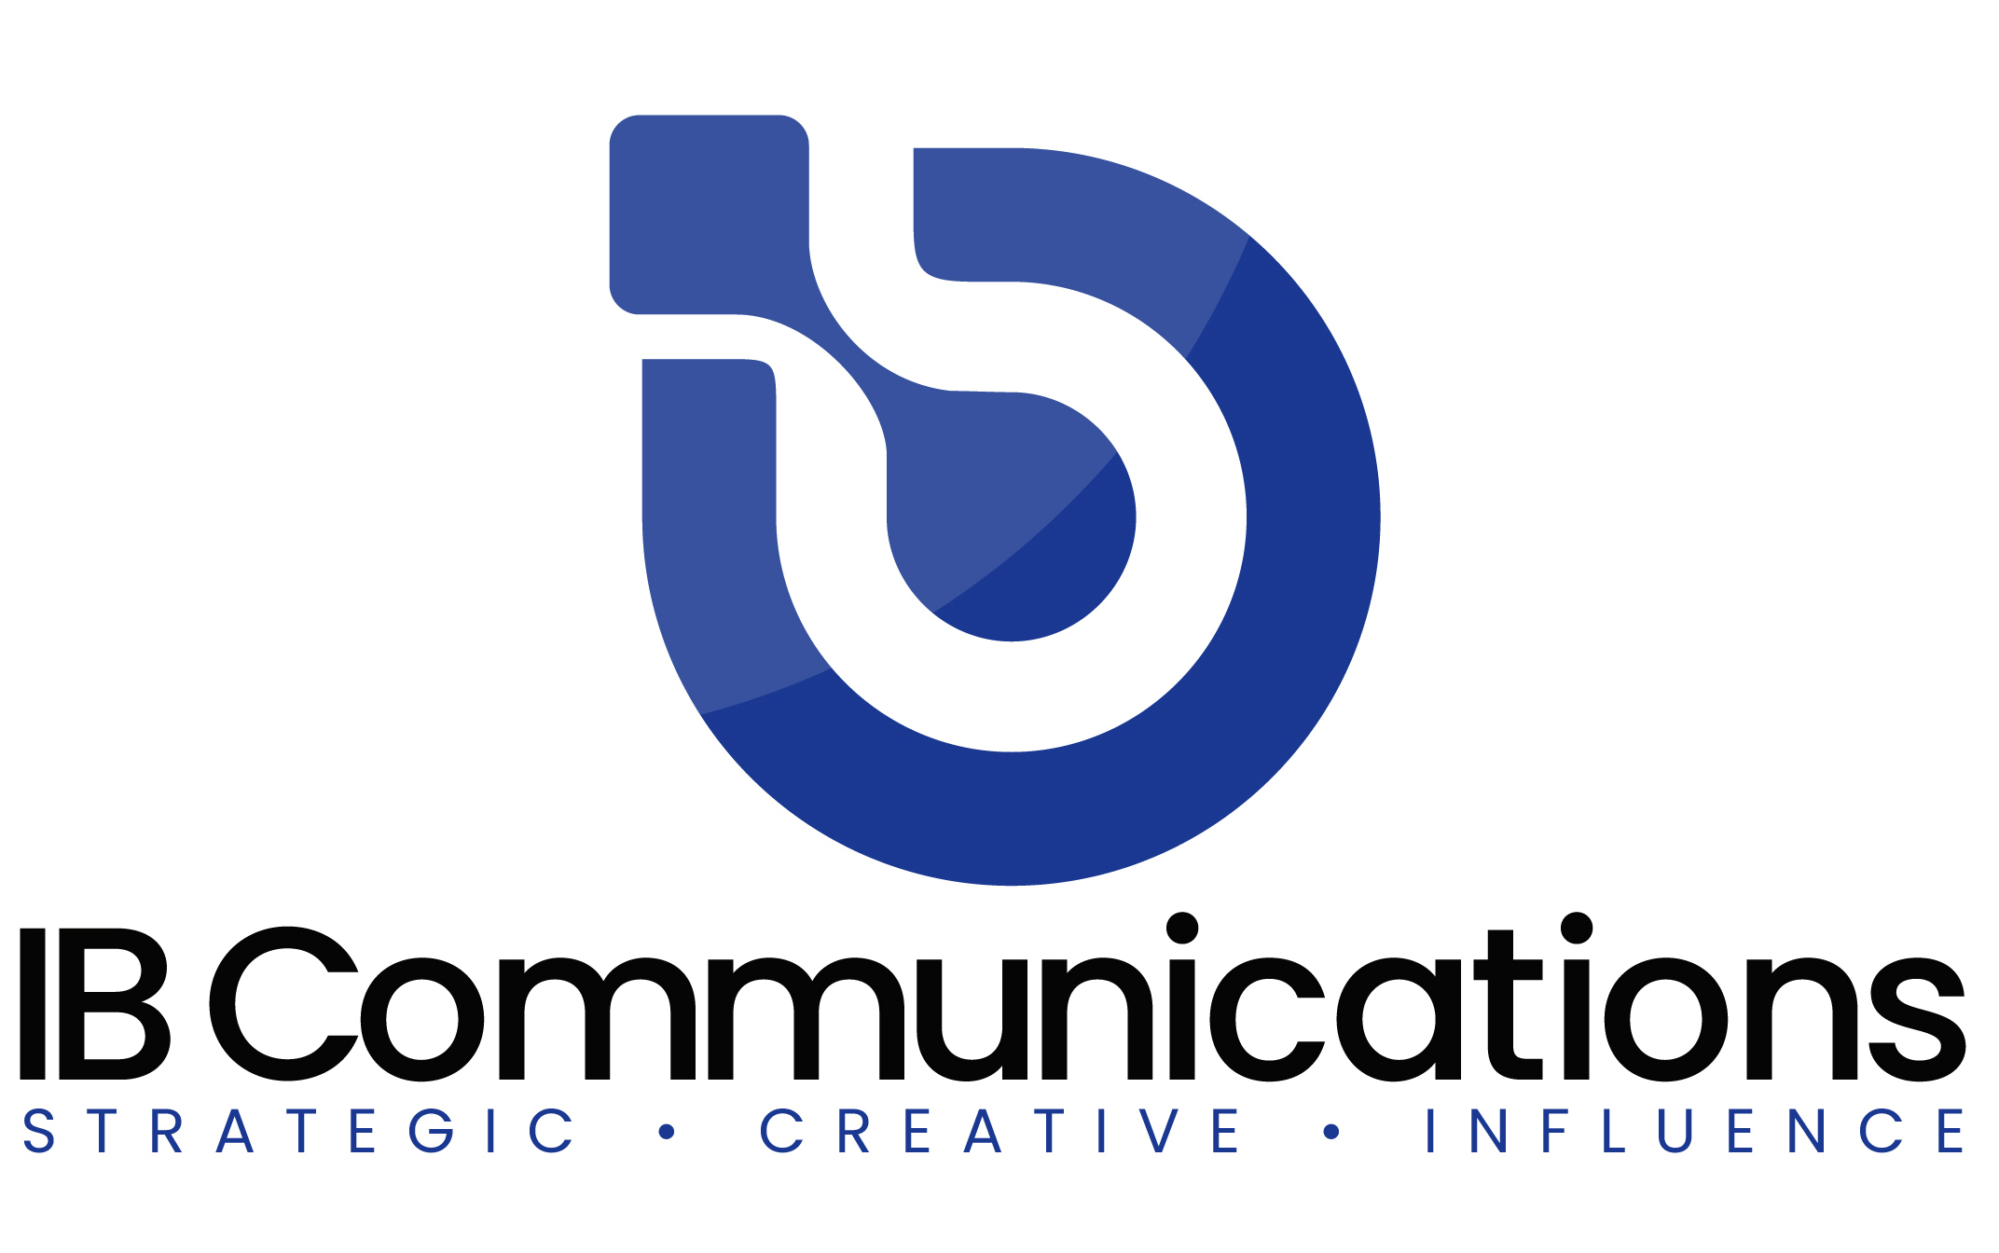

Press Release
Media Contacts:
IB Communications
Tel +44 (0)20 89434685
oribiotech@ibcomms.agency

Ori Biotech and CTMC partner to accelerate novel cell therapy delivery

London, UK, and Houston, TX, US, September 13, 2022 - Ori Biotech (Ori), a leader in cell and gene therapy (CGT) manufacturing technologies, and the Cell Therapy Manufacturing Center (CTMC), a joint venture between National Resilience Inc and MD Anderson Cancer Center, today announce a collaborative partnership to develop industrial manufacturing processes for cell therapies.

The partnership will accelerate process development, clinical implementation, and commercialization of novel cell therapies. The Ori + CTMC partnership will combine Ori’s technology platform with CTMC’s manufacturing capabilities and, in the first instance, will focus on a cell therapy invented by Dr. Sattva Neelapu, Professor of Lymphoma/Myeloma at MD Anderson. The partnership enables CTMC pre-commercial access to Ori’s technology as part of its LightSpeed Early Access Program (LEAP).

“Ori and CTMC have specifically partnered with the goal of increasing patient access to potentially life-saving cell therapies. This partnership will have a considerable impact on the cell therapy field by implementing innovative, digitally enabled process discovery and automated manufacturing solutions,” said Jason C. Foster, CEO, Ori Biotech. “Ori is partnering with leading organizations like CTMC to deliver technology that is fundamental to creating widespread patient access.”

“Ori and CTMC are both focused on accelerating cell therapies to reach more cancer patients earlier. Ori’s automated manufacturing platform enhances our ability to robustly deliver autologous cell therapies for first-in-human clinical studies while also directly leading to eventual scaled commercialization,” said Jason Bock, CEO at CTMC.

Ori and CTMC have highlighted several key objectives for the partnership, including the adaptation and digitization of existing CAR-T processes already in CTMC development labs onto the Ori platform to demonstrate technical feasibility. CTMC will perform process comparability runs to demonstrate successful process transfer and comparison to existing in-house manufacturing processes.

About Ori Biotech
Ori is a London and New Jersey based manufacturing technology company pioneering flexible process discovery with seamless translation and scalable commercialization of cell and gene therapies. Ori has developed a proprietary, full stack manufacturing platform that closes, automates and standardizes CGT manufacturing allowing therapeutics developers to develop and bring their products to market at commercial scale. The promise of the innovative Ori platform is to fully automate CGT manufacturing to increase throughput, improve quality and decrease costs by combining proprietary hardware, software, data and analytics.
Ori was founded in 2015 by Dr. Farlan Veraitch (UCL) and has brought together a seasoned Board and management team with over 200 years of combined pharmaceutical, CGT and venture building experience including CEO Jason C. Foster (Indivior), CBO Jason Jones (Miltenyi), CDOO Kevin Gordon (Tmunity), CTO Stuart Milne (Cytiva), VP Tom Heathman (Minaris), VP David Smith (Minaris), VP Lee Unroe (Indivior), Chris Mason (AVROBIO), Paul Meister (ThermoFisher) and Annalisa Jenkins (Dimension Therapeutics) alongside expert advisers like Bruce Levine, Anthony Davies, and Robert Preti. For more information, visit http://www.oribiotech.com/

About CTMC
The Cell Therapy Manufacturing Center (CTMC), a joint venture between Resilience and MD Anderson Cancer Center, was launched to accelerate the development and manufacturing of innovative cell therapies for patients with cancer. Uniting the strengths of Resilience and MD Anderson, CTMC advances its work within a culture of academic innovation alongside industrial expertise. CTMC operates a 60,000-square-foot manufacturing facility in the Texas Medical Center with a team focused on process and analytical development as well as clinical-stage manufacturing. Learn more at www.ctmc.com.

